**NEXUS**

daily we builds many things where these builds are stored the main purpose of artifactory is to store the builds in an organized manner.If small project its ok to take previous build and run,if it is big project which was run10 years, think how many builds are created and it is difficult to take previous builds.To avoid this confusion ,repositories comes into the picture.

artifactory free version is jfrog

step-1:- "jfrog installation" in google

<https://www.jfrog.com/confluence/display/RTF/Installing+Artifactory>

download jfrog:-

<https://jfrog.com/open-source/>

branching-strategy follows every company, but artifacts is not follow in every company,they might follow s3 bucket or SAN drivers

#############################**OPTION-1**###################################

[**Nexus Server Installation in Linux -**](http://mithuntechnologies-devops.blogspot.com/2019/10/nexus-server-installation-in-linux.html)  
**Login as a root user**  
sudo su -  
cd /opt  
yum install tar wget -y  
wget http://download.sonatype.com/nexus/3/nexus-3.15.2-01-unix.tar.gz  
tar -zxvf nexus-3.15.2-01-unix.tar.gz  
mv /opt/nexus-3.15.2-01 /opt/nexus  
  
**#As a good security practice, Nexus is not advised to run nexus service as a root user, so create a new user called nexus and grant sudo access to manage nexus services as follows.**  
useradd nexus  
  
**#Give the sudo access to nexus user**  
  
visudo  
nexus ALL=(ALL) NOPASSWD: ALL  
  
**#Change the owner and group permissions to /opt/nexus and /opt/sonatype-work directories.**  
  
chown -R nexus:nexus /opt/nexus  
chown -R nexus:nexus /opt/sonatype-work  
chmod -R 775 /opt/nexus  
chmod -R 775 /opt/sonatype-work  
  
**#Open /opt/nexus/bin/nexus.rc file and  uncomment run_as_user parameter and set as nexus user.**  
  
vi /opt/nexus/bin/nexus.rc  
run_as_user="nexus"  
  
**#Create nexus as a service**  
  
ln -s /opt/nexus/bin/nexus /etc/init.d/nexus  
  
**#Switch as a nexus user and start the nexus service as follows.**  
  
su - nexus  
  
**#Enable the nexus services**  
sudo systemctl enable nexus  
  
**#Start the nexus service**  
sudo systemctl start nexus

**#Start the nexus service on browser**

http:// 172.31.37.129:8081 (nexus default port)

**Troubleshooting  
---------------------**  
**nexus service is not starting?**

nexus must be space available 2GB, otherwise it wont run in browser, even if we start the service up and running.

free -h /free -m  
  
a)make sure need to change the ownership and group to /opt/nexus and /opt/sonatype-work directories and permissions (775) for nexus user.  
b)make sure you are trying to start nexus service with nexus user.  
c)check java is installed or not using java -version command.  
  
**Unable to access nexus URL?  
-------------------------------------**  
a)make sure port 8081 is opened in security groups in AWS ec2 instance.

#############################**OPTION-2**###################################

***Install-Nexus-on-EC2-Instance***

*https://www.youtube.com/watch?v=7oYDqtuRVho*

*1)Install GIT*

*2)Install java.*

*3)Install maven*

*4)Install jenkins*

*5)Install Sonaty-Nexus (take another Ec2-instance or same Ec2-Instance where jenkins is installed but mandatory 2GB RAM is available, default PORT 8081 must open in nexus server)*

*6) http:// 172.31.37.129:8081*

*Default credentialsfor Nexus-Server:-*

*admin/admin123*

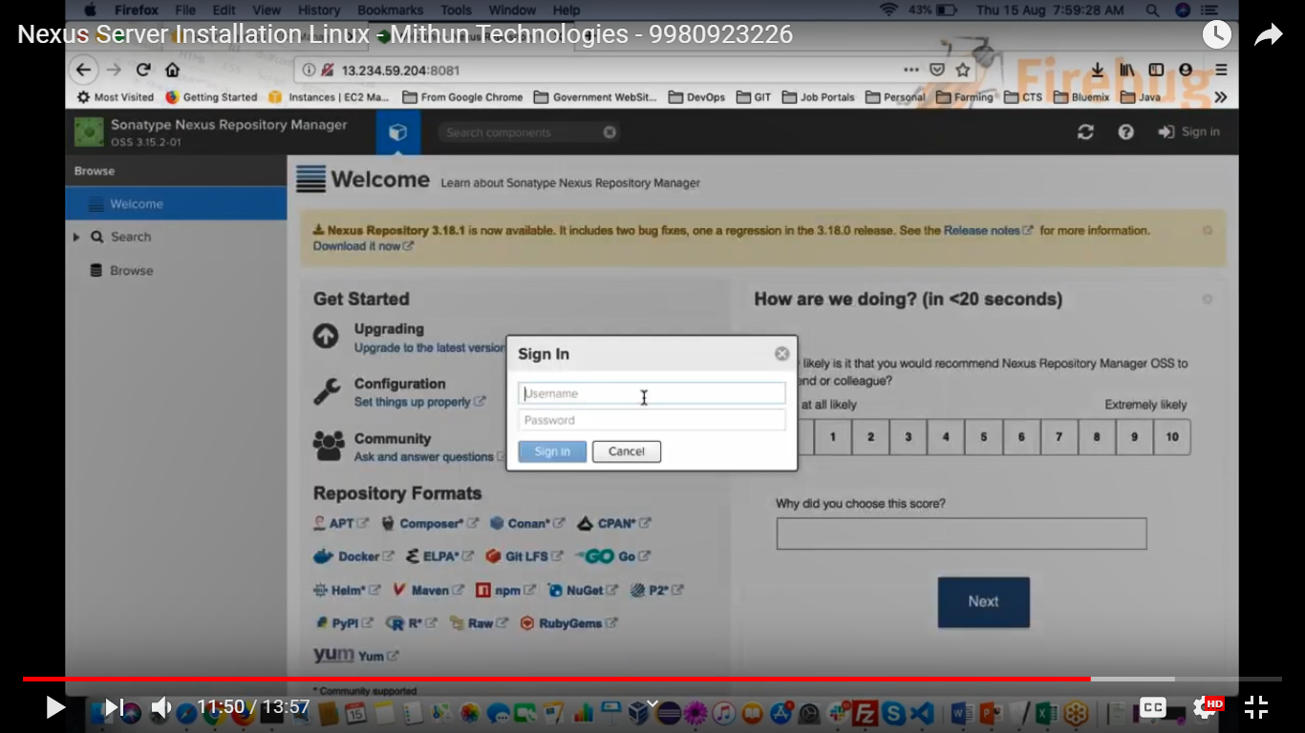

**SUCCESS**

It is best practice to change default user name and password

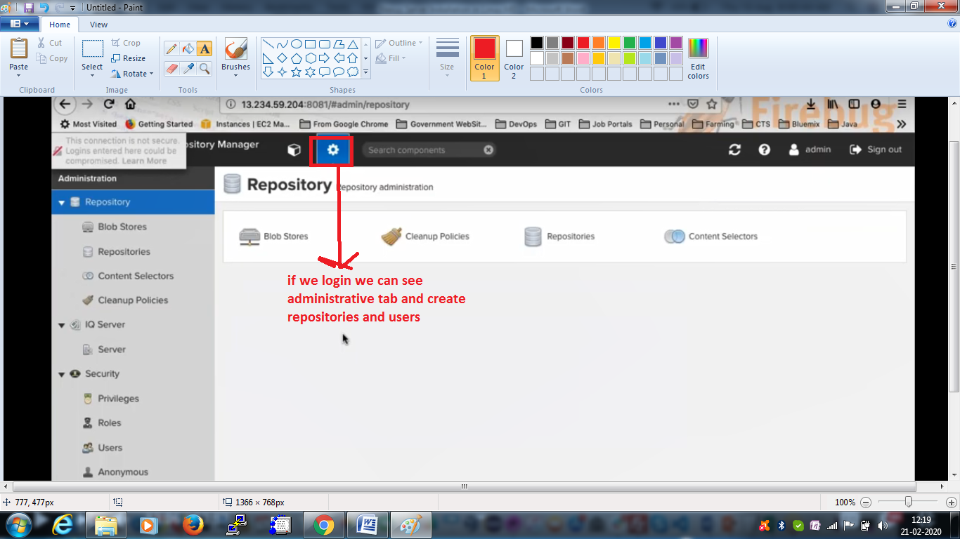

**There are two ways to upload artifacts in Nexus server,once install nexus on EC2-instance**

**A) Integrate Maven(POM.XML) with Sonatype-Nexus to Upload-Artifacts**

https://www.youtube.com/watch?v=qbO4MTESiJQ

**1)Create two repositories :- Snapshot-repository, Release-repository**

**2)Repository------->Create repository----->Maven2(Hosted)**

Name(project-name/any-name)

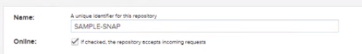

**3) Maven 2---->Version policy---->snapshot**

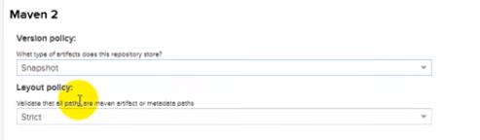

create-repository



***\*\*\*if it any snapshot is created (.war file) it goes to Maven-snapshot repository\*\*\****

**4) Create another repository i.e Maven-Release repository**

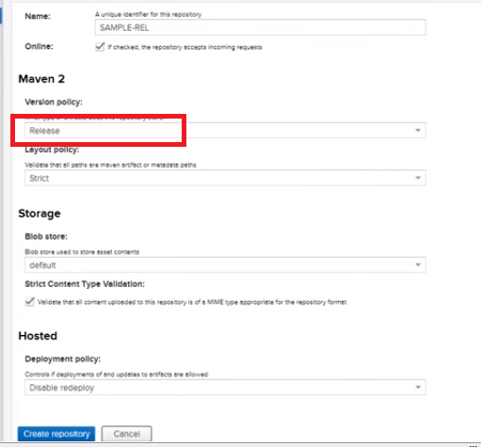

**\*\*\*If there is any release build,it goes to Release-repository\*\*\*\***

**5) copy the url's**

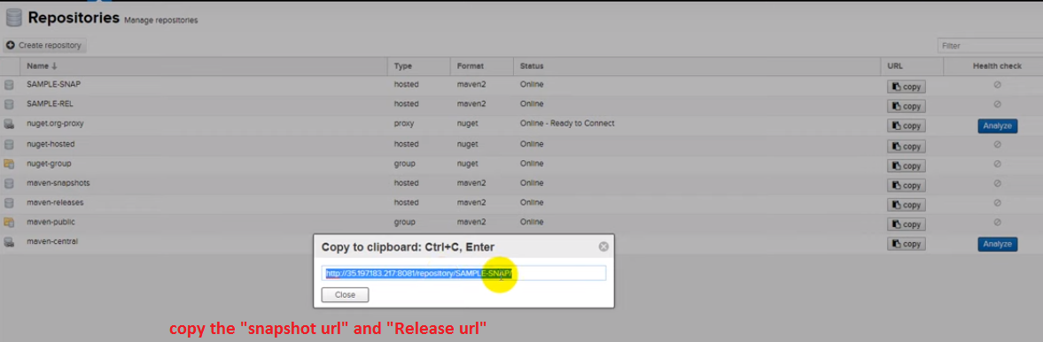

**6) Update pom.xml file in project folder**

**pom.xml**

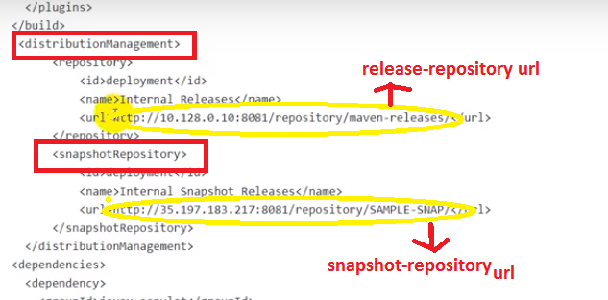

**there is another small configuration your maven should authenticate Nexus to deploy artifacts otherwise throws error "unauthorized"**

**7) [root@Jenkins ~]# vim /etc/maven/setting.xml or bash_profile/M2 settings for individual users**

**nexus-server credentials**

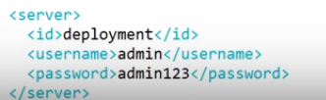

**8) we need to add maven life cycle "deploy"**

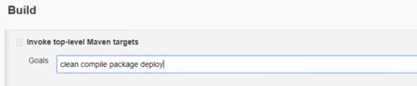



**9) It creates "snap-shot repository**

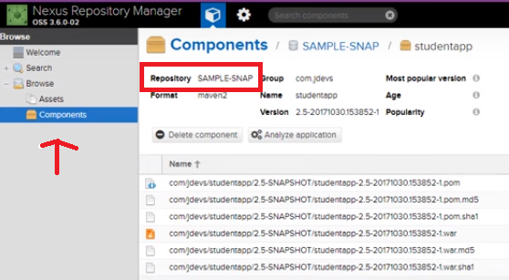

**\*\*\* in existing pom.xml file we mentioned "<version>1.0-SNAPSHOT</version" i.e dev/build only,not production.\*\*\***

**\*\*\*In existing pom.xml file if we mentioned "<version>1.0-RELEASE</version" i.e dev/build/production, it creates release build also\*\*\***

**B) Install Nexus-Plugin-to-Jenkins-Dashboard**

https://www.youtube.com/watch?v=Mde05zXu0O4

**1. Open the Jenkins Dashboard using your Jenkins url.**

**2. Once open the Jenkins Dashboard goto jenkis home ---> ManageJenkins ---> Manage Plugins --> available tab -->search Nexus Platform plugin and click install without restart**

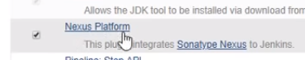

**Note:- check Maven configured or not if you not must configure maven before you build the maven project**

**3. Once upload is done now configure the Nexus server to upload your build artifacts.Then goto Jenkins home --> manage jenkins --> Configure System --> Sonatype Nexus**

**4. And click the Nexus repository manager 3.x server and filled the required coloumns**

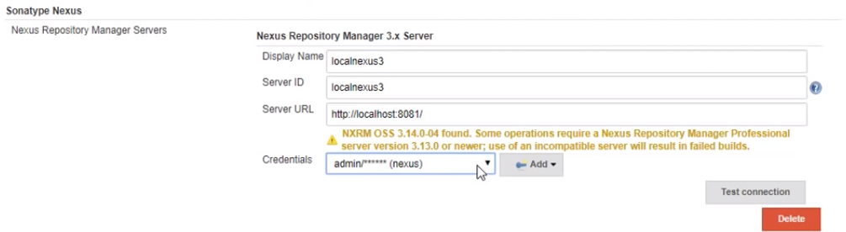

**Note:- Once add Nexus platform plugin then only we can see above screen.**

**5. In jenkins dashboard --. new job and filled the required coloumns**

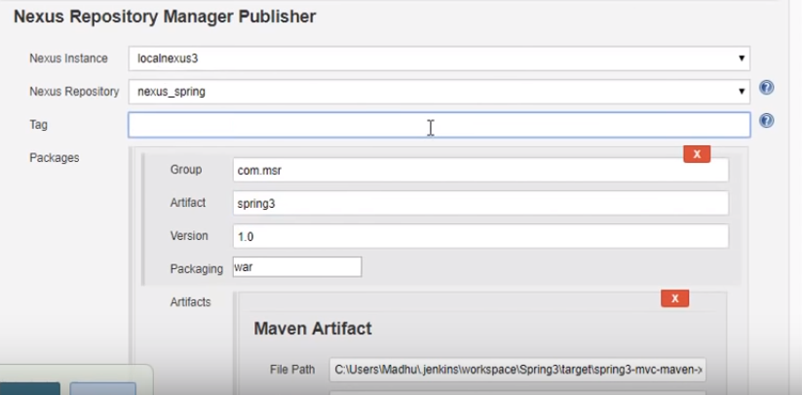

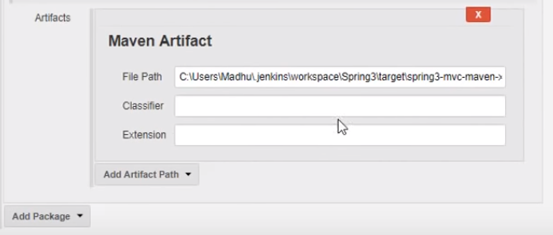

**6. save/apply**

**7. jenkins dashboard --> select job --> buildnow**

**8. In nexus server creates the artifact (.war file)**

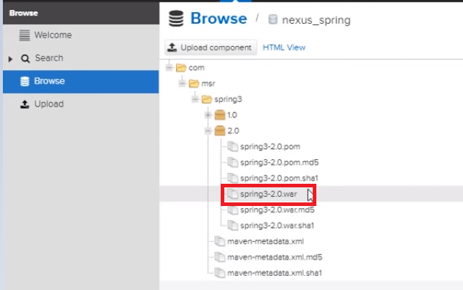

**9. 1.0/2.0 these are versions, inside versions artifacts is stored in single**

**repository.it is easily identified previous builds.**

**Note:- we can download artifact from Nexus sever:-**

**1. use curl command to login nexus server in linux machine and download artifact and deploy into target tomcat server ----> webapp folder**

**or**

**2. use "wget nexus reposity url" command to download and deploy into target server.**

**############################# DONE ############################################**